Used data from UK rows in the country column of UKBMS _collated. Calculated yearly growth rates for each species using TR0OBS. This was done by creating a second column of TR0OBS, lagging by one year. The growth rate was calculated by TR0OBS – TR0OBS (previous year).

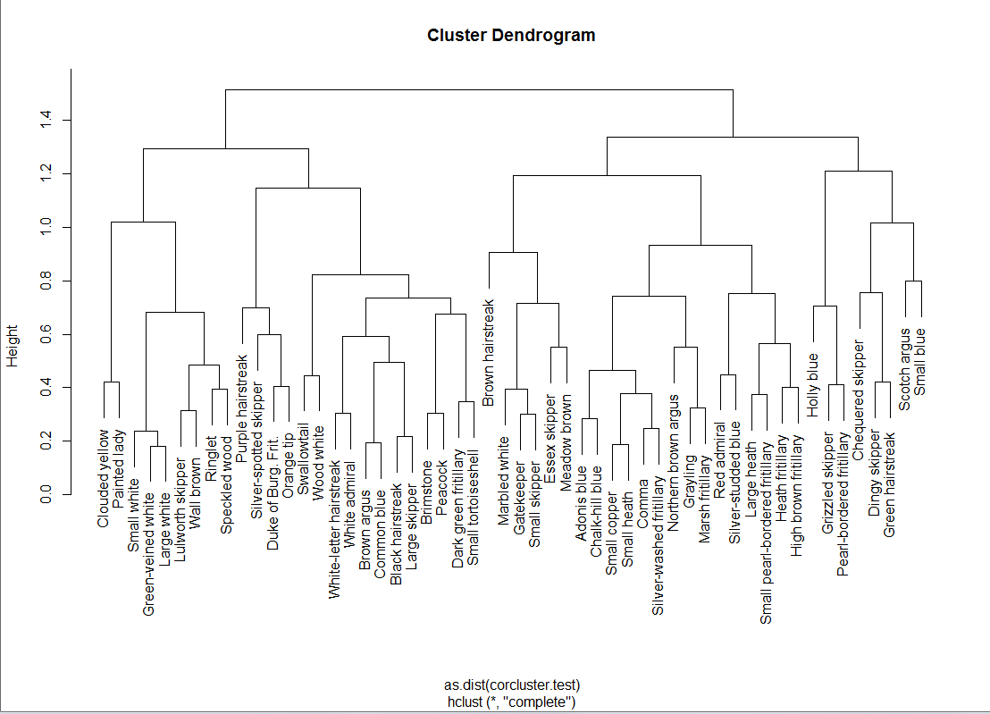Using the growth rates for each species for each year a correlation matrix was created. This gave a correlation value of the growth rates for each species against every other species i.e. a synchrony socre. This matrix was then used to create a dendrogram which joins the two closest values iteratively until it forms a single cluster. The lower the value on the y axis at which two clusters (or individuals) meet, the closer their synchrony scores.

The dendrogram can be split (arbitrarily) into distinct clusters at points along the Y axis. This can be done at each new branch. Three levels of increasing similarity were selected (lines in red) to look at clusters

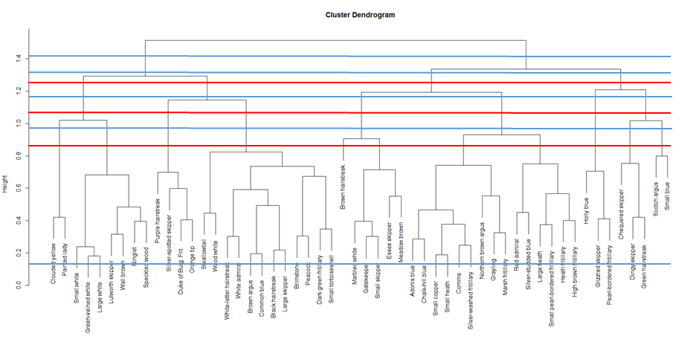

|  |  |  |  |
| --- | --- | --- | --- |
| Species | Level 1- 4 Clusters | Level 2- 8 clusters | Level 3- 11 clusters |
| Clouded yellow | A | A | A |
| Painted lady | A | A | A |
| Green-veined white | A | B | B |
| Large white | A | B | B |
| Lulworth skipper | A | B | B |
| Ringlet | A | B | B |
| Small white | A | B | B |
| Speckled wood | A | B | B |
| Wall brown | A | B | B |
| Black hairstreak | B | C | D |
| Brimstone | B | C | D |
| Brown argus | B | C | D |
| Common blue | B | C | D |
| Dark green fritillary | B | C | D |
| Duke of Burg. Frit. | B | C | C |
| Large skipper | B | C | D |
| Orange tip | B | C | C |
| Peacock | B | C | D |
| Purple hairstreak | B | C | C |
| Silver-spotted skipper | B | C | C |
| Small tortoiseshell | B | C | D |
| Swallowtail | B | C | D |
| White admiral | B | C | D |
| White-letter hairstreak | B | C | D |
| Wood white | B | C | D |
| Brown hairstreak | C | D | E |
| Essex skipper | C | D | F |
| Gatekeeper | C | D | F |
| Marbled white | C | D | F |
| Meadow brown | C | D | F |
| Small skipper | C | D | F |
| Adonis blue | C | E | G |
| Chalk-hill blue | C | E | G |
| Comma | C | E | G |
| Grayling | C | E | G |
| Heath fritillary | C | E | H |
| High brown fritillary | C | E | H |
| Large heath | C | E | H |
| Marsh fritillary | C | E | G |
| Northern brown argus | C | E | G |
| Red admiral | C | E | H |
| Silver-studded blue | C | E | H |
| Silver-washed fritillary | C | E | G |
| Small copper | C | E | G |
| Small heath | C | E | G |
| Small pearl-bordered fritillary | C | E | H |
| Grizzled skipper | D | F | I |
| Holly blue | D | F | I |
| Pearl-bordered fritillary | D | F | I |
| Chequered skipper | D | G | J |
| Dingy skipper | D | G | J |
| Green hairstreak | D | G | J |
| Scotch argus | D | H | K |
| Small blue | D | H | K |

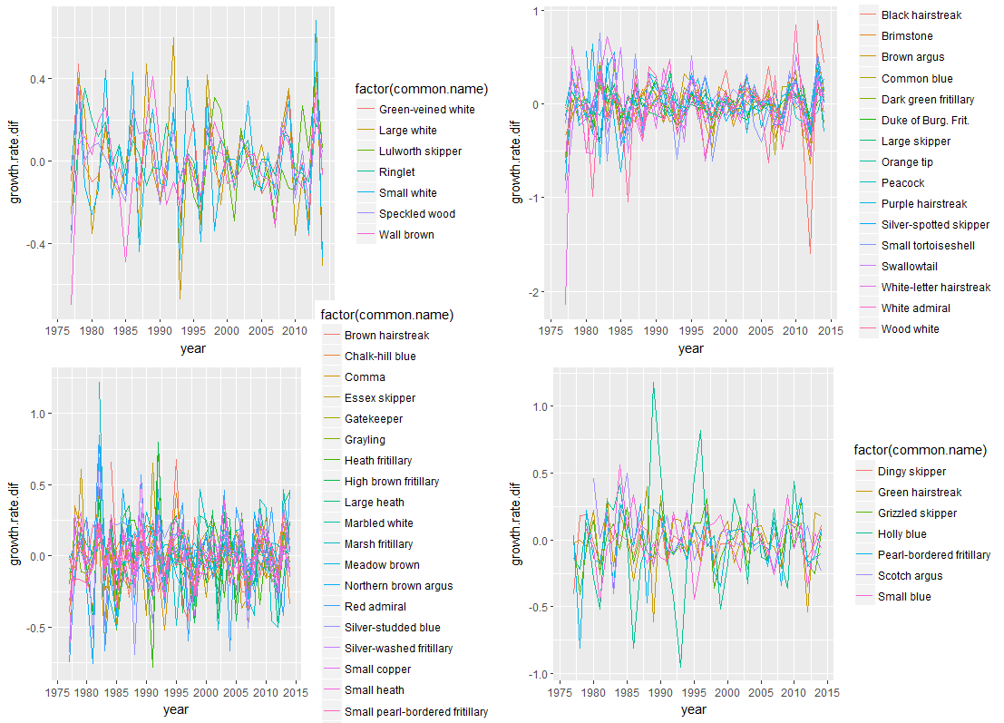At the lowest level there are four clusters (A-D)

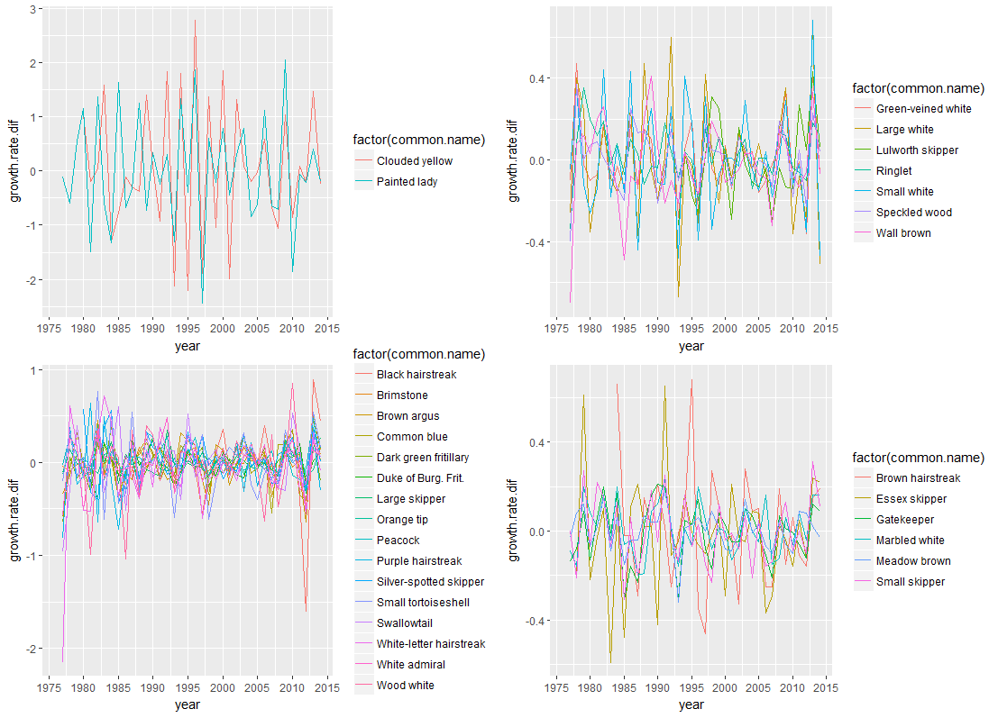The next level gives eight clusters (A-H)

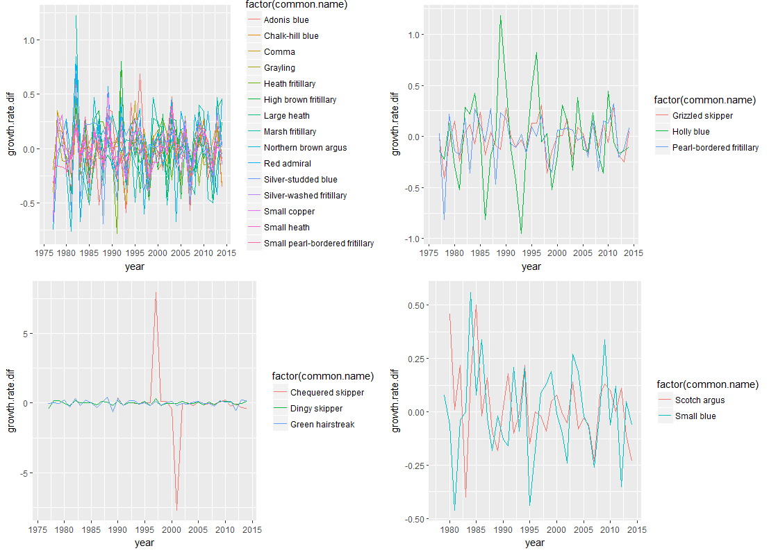

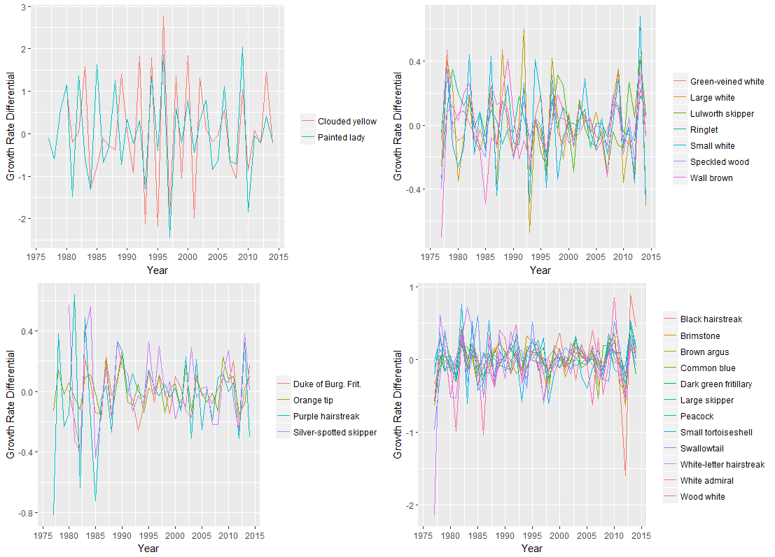The final level selected gives 11 clusters (A-K).

